Final Demonstration

Our final demonstration must use steaming, mapping, simulation, multi robot communication, and waypoints. We want to use these features to show off our work but we don’t want to overextend and not be done by finals.  
Here is an example demonstration that is simple to implement and still looks cool:

1. Setup
   1. 4 Robots are setup at pre-determined points.
   2. 4 ‘objectives’ are setup at pre-determined points.
      1. One objective is tied to one robot
2. Host determines which objective to reach first. Command is send to corresponding robot with waypoint of objective.
3. Robot determines path to get to waypoint and follows it
   1. Robot path is simulated
   2. Robot returns encoder counts to host to map the robot’s location
4. Robot reaches waypoint and responds to host computer with end location.
5. Host determines the next objective to reach. Command is sent to the corresponding robot to reach the previous robots way point. Then proceed to its objective.
   1. Robot path is simulated
   2. Robot returns encoder counts to host to map the robot’s location
6. Robot reaches waypoint and responds to host computer with end location
7. Repeat steps 5-7 for remaining two objectives

Robot Description

1. Sensors
   1. Two motor encoders
   2. NXTbee
      1. Communication between Lego NXT and Host
   3. Color sensor?
      1. Objective Identifies
2. Motors
   1. Two motors
3. Software
   1. Robot C?
   2. Simulink
4. Raspberry Pi Integration
   1. Raspberry Pi acts as a sensor hub and communicates data to Lego NXT.



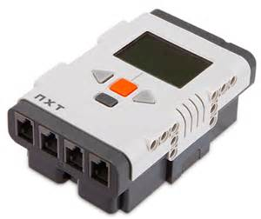



1

2

3

4

Team Leads

* Niki
  + Streaming
  + niki-maleki@utulsa.edu
* Will
  + Multi Robot Communication
  + Was739@utulsa.edu
* Nathanael
  + Simulation
  + Nathanael-rake@utulsa.eud
* Lindsay
  + Mapping
  + lindsay-flasch@utulsa.edu
* Garett
  + Waypoint Following
  + garrett-stafford@utulsa.edu